Evidence for Analysis and Design Unit

Joe Stafford

E21

A.D.1 Use case Diagram

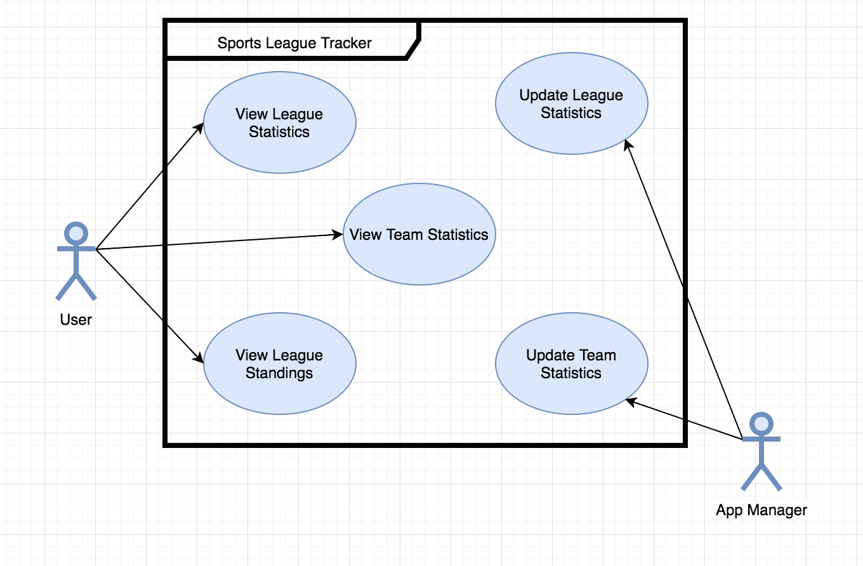

A.D.2 Class Diagram

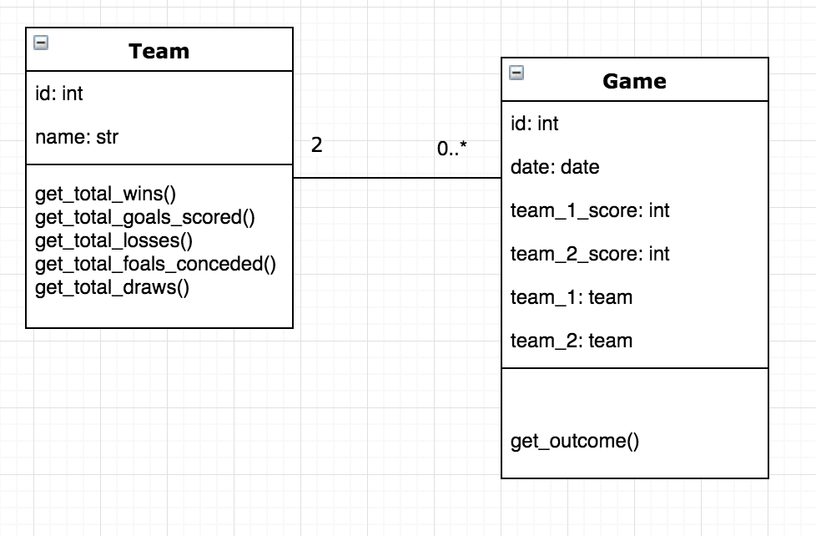

A.D.3 Object Diagram

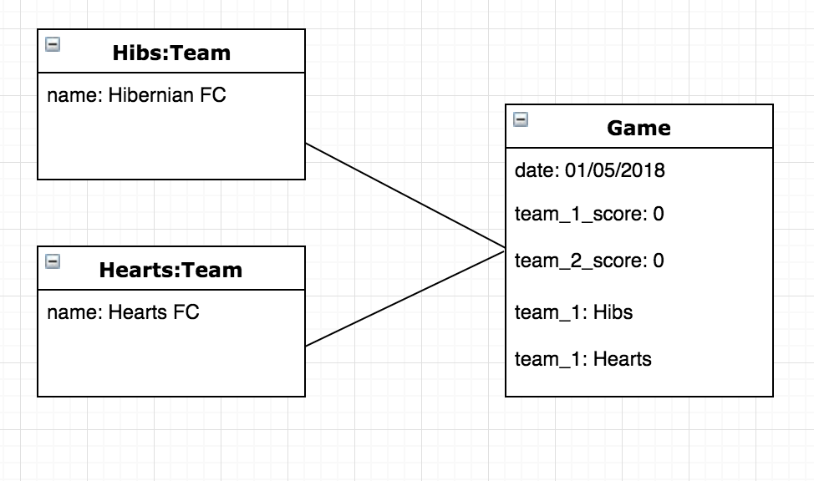

A.D.4

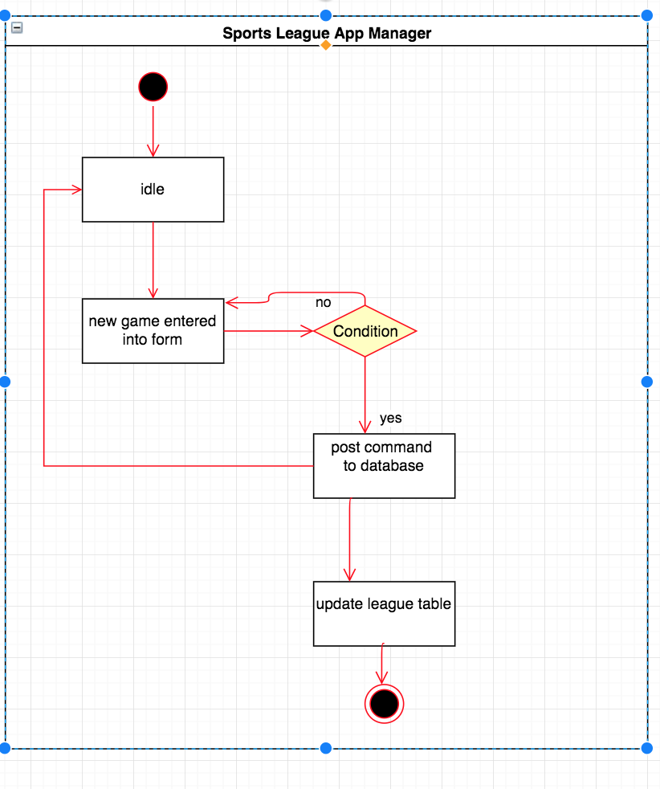

A.D.6

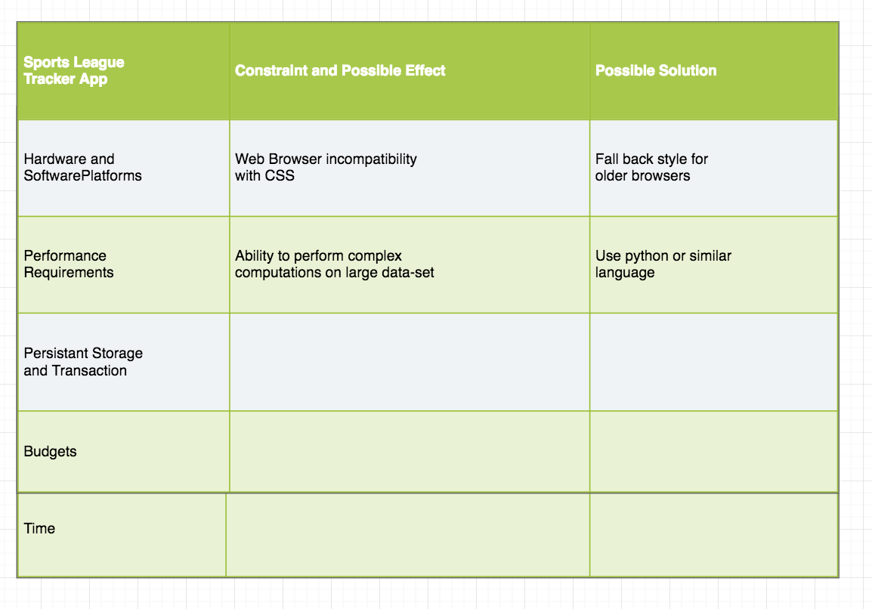

A.D. 5 - An​ ​Inheritance​ ​Diagram

